LIMIT REFERENCE POINTS AND WILD SALMON POLICY RAPID STATUS SUMMARY:

2023 FRASER – LOWER FRASER FALL 0.3 STOCK MANAGEMENT UNIT

Context
A key recommendation from a CSAS peer review process on Pacific Salmon Limit Reference Points (LRPs) is ‘CU [conservation-unit] status-based LRPs’ be used to meet the Fish Stocks provisions of the Fisheries Act (DFO 2022; Holt et al. 2023a, 2023b), which was supported nationally (DFO 2023). LRP's are assessed for Stock Management Units (SMUs), which can include one or more conservation units (CUs) (i.e., CUs are nested within SMUs). Using this approach, serious harm to a SMU is identified when any component CU zone drops into the Wild Salmon Policy (WSP) Red zone. Under this definition, the CU status-LRP is ‘100% of CUs with statuses above Red status’. The implications are that if a single CU is the Red status zone, the SMU is assessed as being below its LRP, which in turn triggers a DFO rebuilding plan for the SMU.

Forewords
While expert reviewers expressed concerns that the Wild Salmon Policy Rapid Status Algorithm does not account for changes in spawner distribution within CUs, the Lower Fraser Fall 0.3 SMU contains a single Chinook population. Thus, the incorporation of a spawner distribution metric is not a concern for this SMU.

Data
The Lower Fraser Fall 0.3 Chinook SMU contains a single CU with one ocean-type populations of Chinook, and a single stream used in its assessment. The data used in this assessment were described in detail in Dionne et al. (2023). The last integrated status assessment for this single CU SMU occurred for return year 2012 (DFO 2016). Some of the data were also recently used in the Fraser Chinook Recovery Potential Assessments (Weir et al. 2022).
Spawner enumeration of Harrison River Chinook has been accomplished via mark and recapture since 1984. Pre-1984 data were generated with unreliable visual surveys (abundances estimates were unrealistically low) and will be removed as a revision to this document after the January 31st meeting, 2025.
Key steps in the data processing of this data set includes assessing data quality, which are described in detail in Pestal et al. (2023). Data quality is assessed based on the number and completeness of surveys, coverage of the spawning period, visibility and reliability records, and methodology.
Spawner abundance data are high quality due to the long-running mark recapture.
Relative Abundance Benchmarks:
Relative-abundance based benchmarks for the single CU in this SMU were calculated from a Ricker stock recruit model fit to the Harrison River time series. The 50th percentile benchmarks are presented for this CU in Table 2.
Table 1. Conservation Units (CUs) included in this Stock Management Unit (SMU) and lists of the streams/populations within each CU used in the Rapid Status Assessment. Streams have their NuSEDS population identifications in brackets.
CU No# | CU Name | Streams (Population ID) | Timeseries
CK-03 | Lower Fraser River FA 0.3 | Harrison River (46034) | 1975-2023

Table 2. Relative abundance-based benchmarks by Conservation Unit (CU). The upper benchmarks are 85% S_{MSY} and the lower benchmarks are S_{gen}. Benchmarks. Upper Benchmarks are multiplied by 1.1 in the algorithm.
CU Name | Benchmark | p50
Lower Fraser FA 0.3 | 85% S_{MSY} | 63,808
Lower Fraser FA 0.3 | S_{gen} | 15,318

WSP Rapid Status Summary
Stock Management Unit (SMU) Limit Reference Point (LRP) status and narrative based on expert consensus
There is 1 CU in the Lower Fraser Fall 0.3 SMU and it is designated as 1 Amber, placing this SMU above the LRP in terms of WSP rapid status (Figures 1-2 & Table 3).

Lower Fraser FA 0.3
It was mentioned in the expert review meeting that the Lower Fraser FA 0.3 CU is expected to change back to green in 2024 due to the strong return and high escapement estimate.
Future work: No future work suggested.
Table 3. Wild Salmon Policy (WSP) Rapid Statuses for 2023. For background, refer to Appendix 1.
CU # | CU Name | WSP Rapid Status (YYYY) | WSP Rapid Status Node and Pathway
CK-03 | Lower Fraser FA 0.3 | AMBER,  HIGH | The recent year’s status (2023) is designated Amber with a high confidence based on the algorithm. The data could be assessed as Absolute Abundance. The recent generational average is 66,871 spawners, and is above the relative lower abundance benchmark (Node 37; Figure 2, Table 4), but not above the benchmark plus a 10% buffer (the threshold that needs to be crossed to result in a green status). This Amber status is consistent with the previous the status in 2022 (Figure 1). The 2023 WSP rapid status of Amber does not match the Green WSP integrated status from 2012 (DFO 2020).

CK-03 Lower Fraser FA 0.3
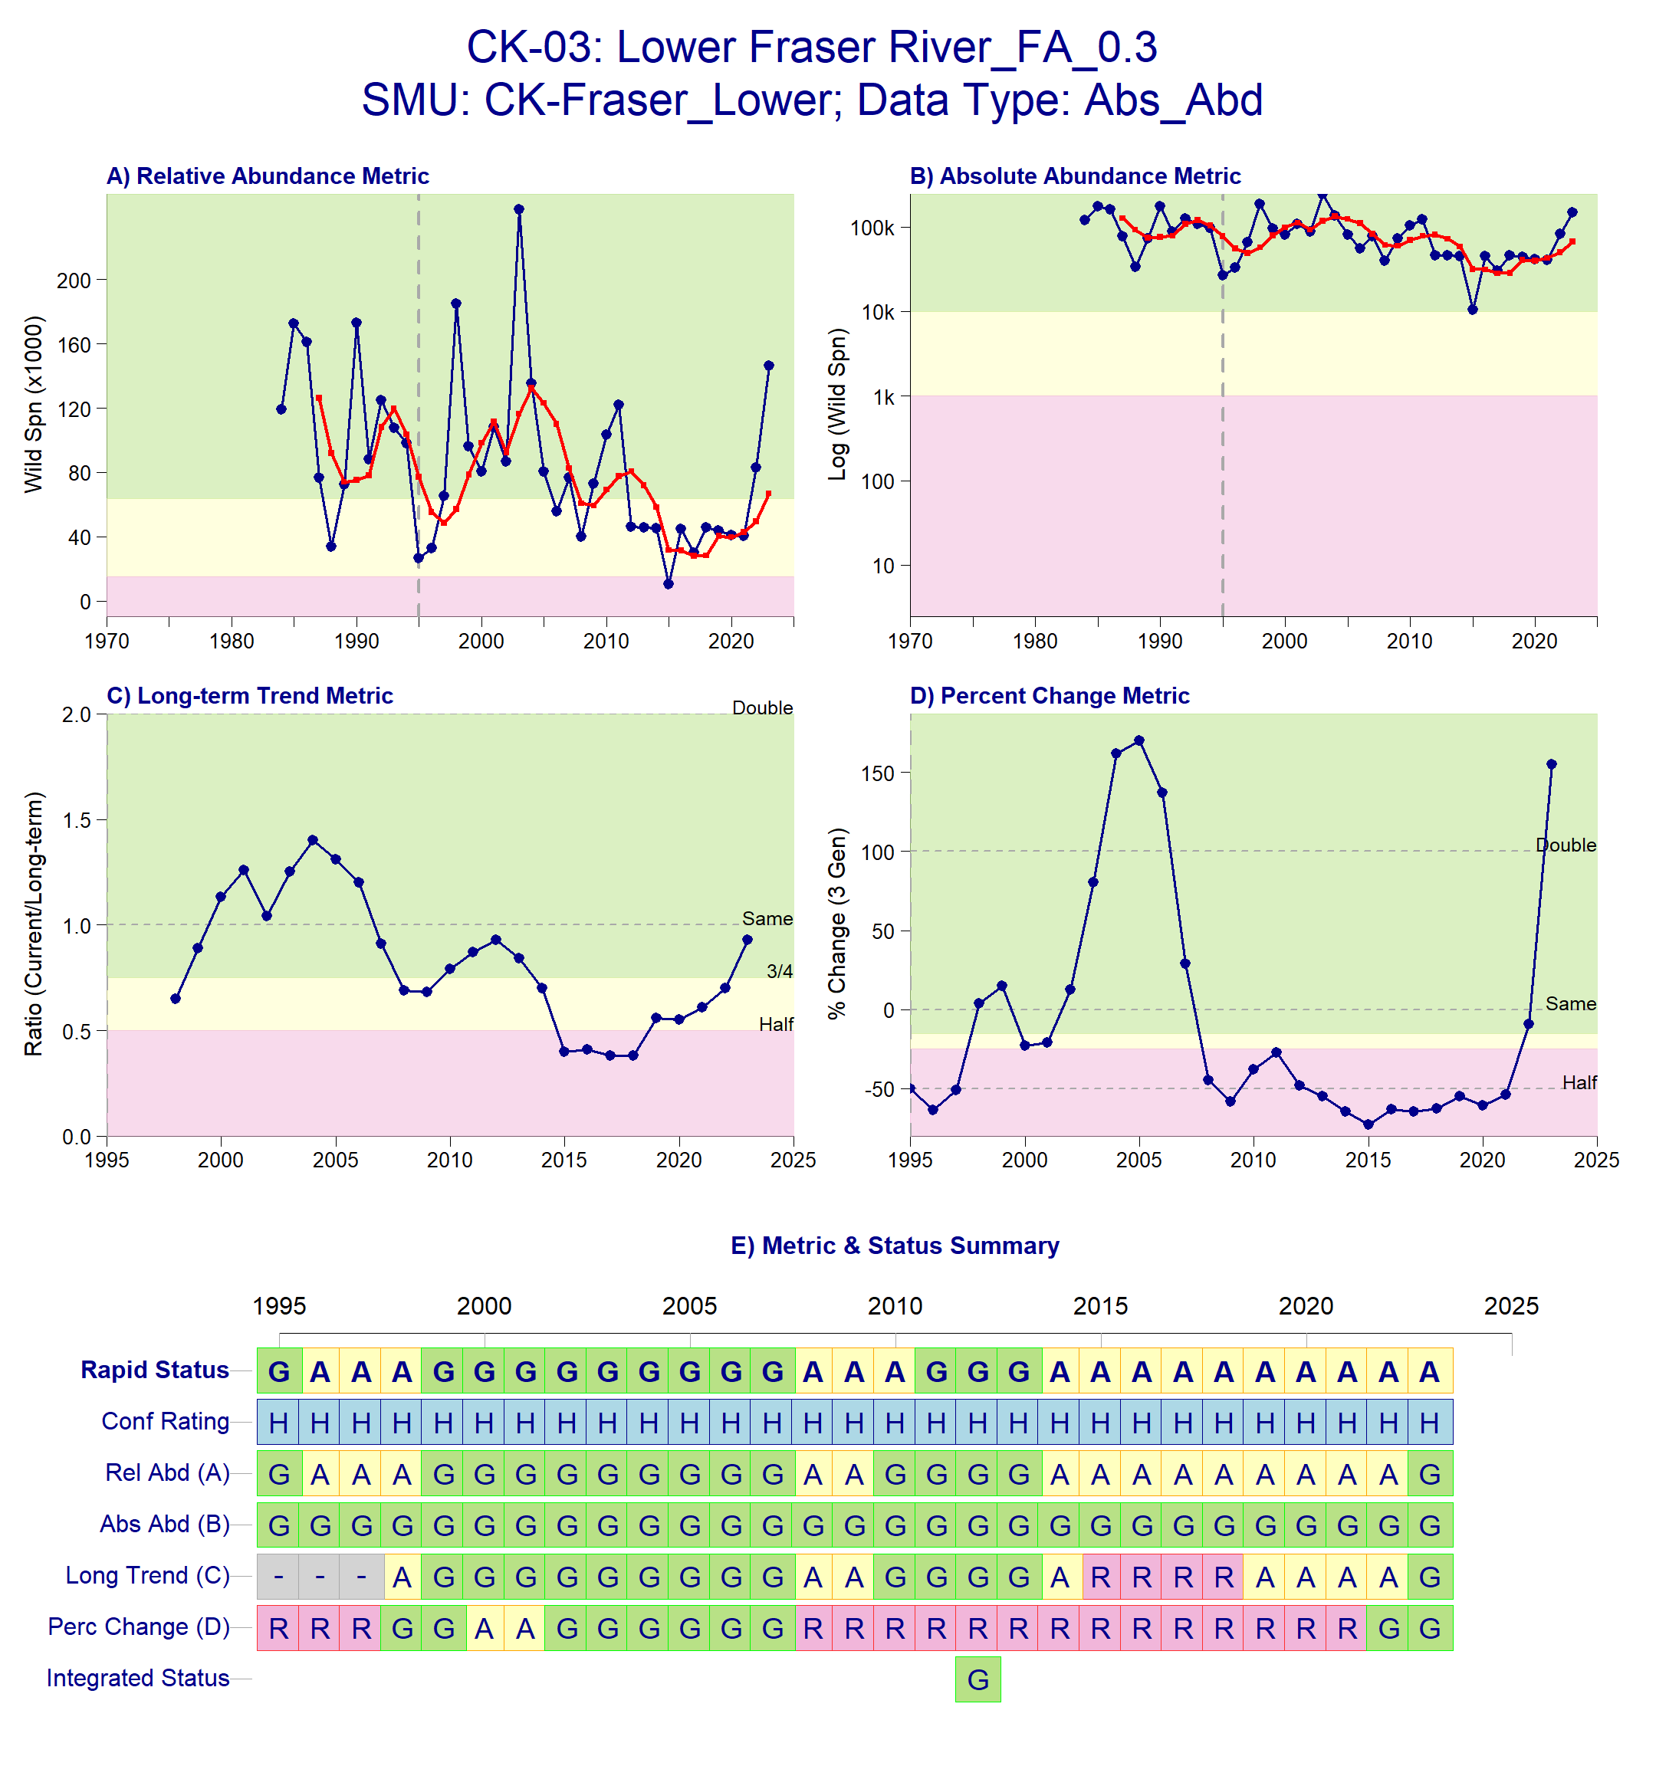
Figure 1: Metrics and Status for Lower Fraser Fall 0.3 (CK-03). Panels on top show the four standard WSP metrics, calculated based on the available time series of spawner abundances. Bottom panel summarizes the status for each individual metric and shows the resulting WSP rapid status for the CU with a confidence rating. If integrated WSP status assessments have been completed for this CU, they are shown on the last row (IntStatus). Note that metric benchmarks may differ from algorithm thresholds, since thresholds approximate the status determination process from past WSP integrated status assessments (see Figure 2 and Table 4).
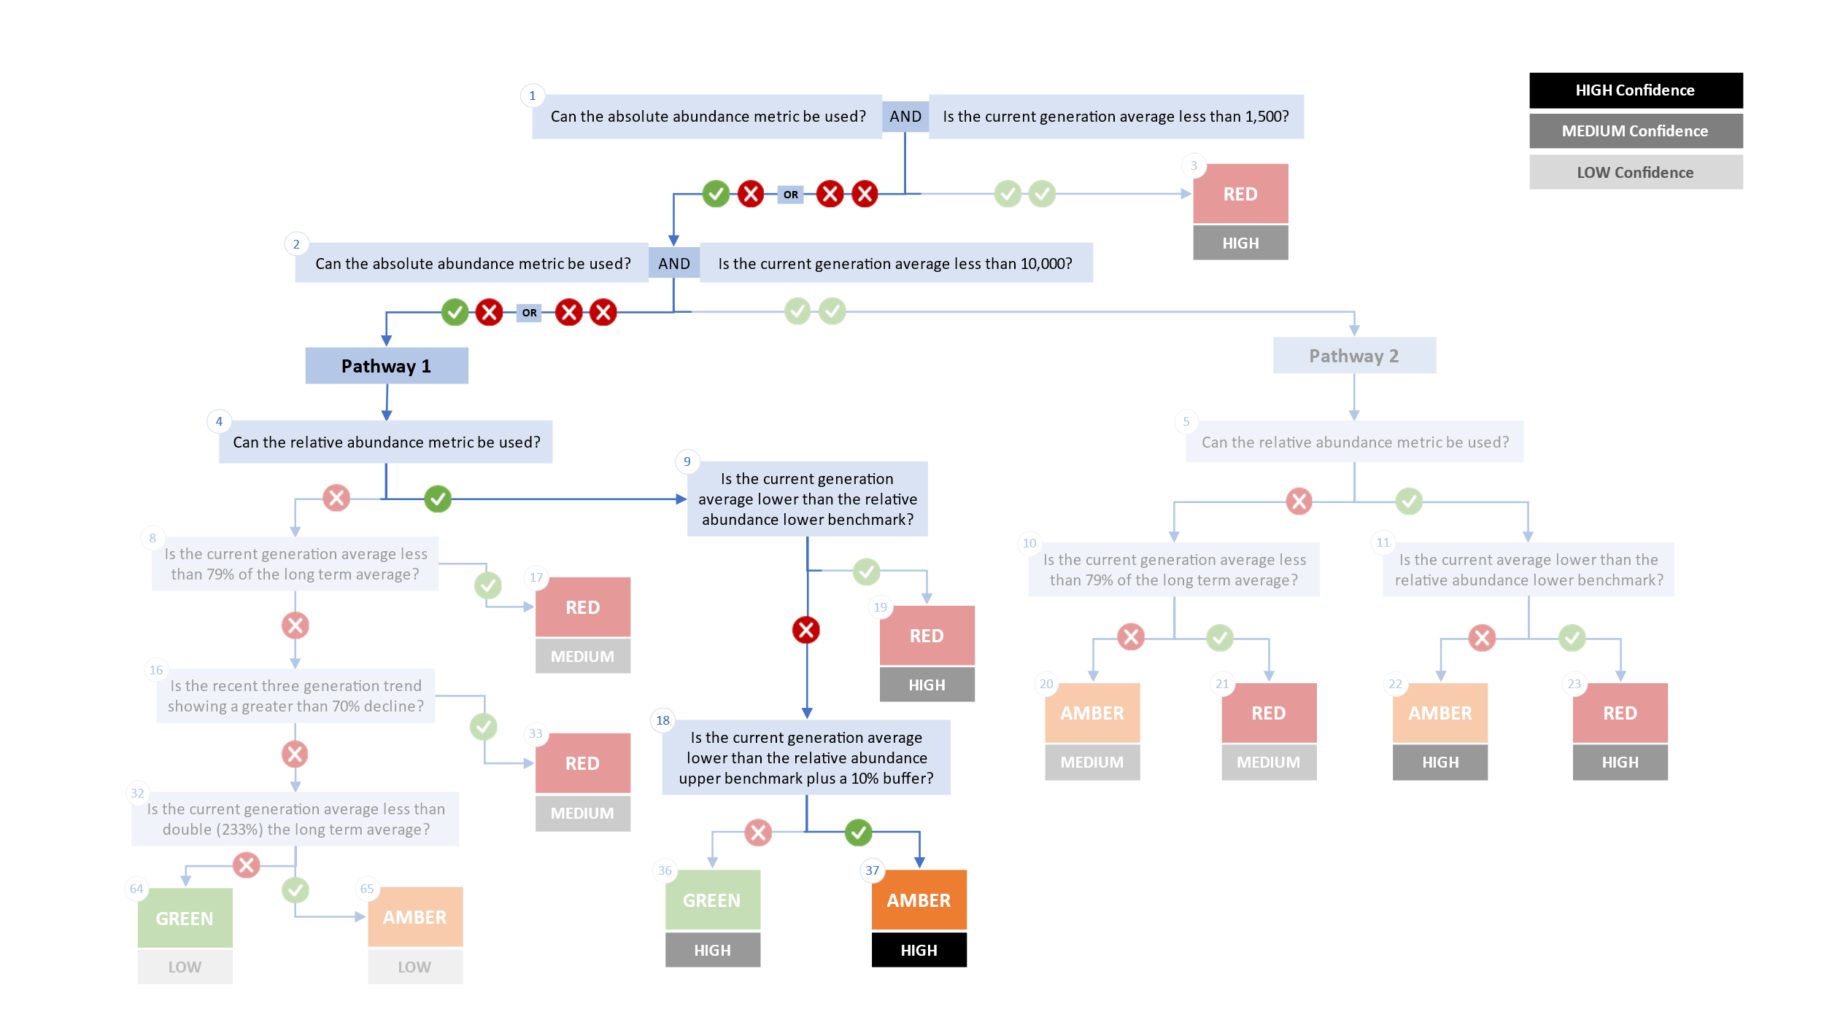
Figure 2. Algorithm pathway taken to assess status for the Lower Fraser Fall 0.3 in 2023. Absolute abundance data is available for this CU (follow to node 2 and 4). Able to compare the abundance to relative abundance benchmark (follow to node 9). The current generational average is lower than the relative abundance lower benchmark threshold used by the algorithm (follow node 18). Status for this CU is therefore designated as Amber with High confidence at node 37 (see DFO 2024 for definition of each node)
Table 4: Decision tree path given data and metric values for the Lower Fraser Fall 0.3 in 2023; this aligns with Figure 2 above. For each node, the algorithm decision is made by comparing the CUs current metric value to the metric threshold and answering Yes or No, running through sequential nodes and decisions until the final WSP rapid status for that CU and year is reached.
Node | Metric | Metric Threshold | CUs Current Value | Decision
1 | Absolute Abundance | <1,500 | 66,871 | YES, NO
2 | Absolute Abundance | < 10,000 | 66,871 | YES, NO
4 | Relative Abundance | Available? |  | NO
9 | Relative Abundance | <78,553 | 66,871 | YES
37 | FINAL STATUS NODE |  |  | AMBER,HIGH

Cited and other Key References
DFO. 2016. Integrated biological status of Southern British Columbia Chinook salmon (Oncorhynchus tshawytscha) under the Wild Salmon Policy.
DFO. 2022. Methodologies and guidelines for defining limit reference points for Pacific Salmon. CSAS SAR 2022/030. pp. 16.
DFO. 2023. Science advice on guidance for limit reference points under the fish stocks provisions. Canadian Science Advisory Secretariat Science Advisory Report 2023/009(February).
DFO. 2024. Rapid status approximations for Pacific salmon derived from integrated status assessments under DFO’s Wild Salmon Policy. Can. Sci. Advis. Sec. Sci. Resp. 2024/004: 1–42. Nanaimo, BC. Available from https://waves-vagues.dfo-mpo.gc.ca/library-bibliotheque/41207890.pdf [accessed 17 November 2024].
Dionne, K., Parken, C., Weir, L., Doutaz, D., Bailey, R., Jenewein, B., Miller-saunders, K., Labelle, M., Welch, P., Trouton, N., Mozin, P., and Walsh, M. 2023. Recovery Potential Assessment for Southern British Columbian Chinook Populations , Fraser and Southern Mainland Chinook.
Holt, Carrie.A., Holt, K., Wor, C., Warkentin, L., Connors, B., Grant, S.C.H., and Huang, A.-M. 2023a. Guidelines for Defining Limit Reference Points for Pacific Salmon Stock Management Units. Can. Sci. Adv. Sec. Res. Doc. 2023/009: iv + 66.
Holt, K., Holt, C.A., Warkentin, L., Wor, C., Davis, B., Arbeider, M., Bokvist, J., Crowley, S., Grant, S.C.H., Luedke, W., McHugh, D., Picco, C., and Will, P. Van. 2023b. Case Study Applications of LRP Estimation Methods to Pacific Salmon Stock Management Units. Can. Sci. Advis. Sec. Res. Doc. 2023/010: iv + 129.
Pestal, G., Macdonald, B.L., Grant, S.C.H., and Holt, C.A. 2023. State of The Salmon: Rapid status assessment approach for Pacific salmon under Canada’s Wild Salmon Policy. Can. Tech. Rep. Fish. Aquat. Sci. (3570): 1–200.
Weir, L., Doutaz, D., Arbeider, M., Holt, K., Davis, B., Wor, C., Jenewein, B., Dionne, K., Labelle, M., Parken, C., Bailey, R., Velez-Espino, A., and Holt, C. 2022. Recovery potential assessment for 11 designatable units of Fraser River chinook salmon, Oncorhynchus tshawytscha, part 2 : elements 12 to 22. Canadian Science Advisory Secretariat (CSAS), Ottawa, ON.

Appendix A: WSP rapid status approach details

The decision tree sequence is as follows (see Figure A1; Table A1, A2):
- The first question is whether or not a CU has a current absolute abundance value, and if so, whether or not this value falls below the lower threshold of 1,500 (which adds a buffer to Committee on the Status of Endangered Wildlife in Canada (COSEWIC) Criterion D1 for small population size of 1,000). If the answer to this question is Yes, then the CU is assigned Red (node 3), with High confidence.
- If the answer to the first question is No, then the second question is whether or not the CU has a current absolute abundance value, and if so, whether or not the current abundance is below the upper threshold of 10,000, which is COSEWIC's Criterion C upper benchmark. This second question splits the decision nodes into two Pathways: Pathway 1 (No to this question) and Pathway 2 (Yes to this question).
  - Pathway 1: is where a CU either does not have a current absolute abundance value, or has these data, and it falls above the upper threshold for this metric. This pathway is split with the question: can this CU be assessed with a relative abundance metric. If the answer is Yes, a Red (nodes 19), Amber (nodes 37) or Green (node 36) WSP rapid status is assigned, with High confidence, depending on where the current abundance value falls relative to this metric’s lower and upper thresholds. If the answer is NO, then comparisons are made between the CUs current abundances and percent change to thresholds for these metrics, which assign a Red with Medium confidence, or Green or Amber with Low confidence status.
  - Pathway 2: is where a CU has absolute abundance data, and these abundances fall between the lower and upper thresholds. In this pathway, absolute abundances restrict WSP rapid statuses to only Amber or Red. This pathway is split with the question: can this CU be assessed with a relative abundance metric. If the answer is Yes, an Amber (node 22) with Medium confidence, or Red (node 23) with High confidence, is assigned, depending on whether the CUs current abundance value falls above the relative abundance metric lower threshold or below. If the CU cannot be assessed with a relative abundance metric, then it is compared to the lower threshold of the Long-Term trend metric and assigned Amber (node 20) with Medium confidence if above, or Red (node 21) with Medium confidence if below.

Table A1. Biological status zones under the Wild Salmon Policy (WSP).

Status |  | Definition
 | Red | Poor status CU facing an imminent threat of extinction [revised definition, given alignment with COSEWIC Endangered statuses]
 | Amber | “While a CU in the Amber zone should be at low risk of loss, there will be a degree of lost production. Still, this situation may results when CUs share risk factors with other, more productive units”. Aligns with COSEWIC Threatened and Special Concern statuses.
 | Green | “identif[ies] whether harvest are greater than the level expected to provide on an average annual basis, the maximum annual catch for a CU, given existing conditions…there would not be a high probability of losing the CU”. Aligns with COSEWIC Not at Risk statuses.
 | DD | Data deficient. CUs have been designated as DD if there is no data available, or if the available data is insufficient for calculating status metrics (after quality control).

Table A2. WSP rapid status Learning Tree 3 status assignments by node (see Figure 1). This table presents the decisions in Learning Tree 3 that led to Red or Amber or Green status assignments; status outcomes depend on the pathway and decisions made. The final node that corresponds to the status assignment is presented below (see Figure 1).
Node | Status | Rule
Node3 | Red | Data Type is Absolute Abundance AND Absolute Abundance < 1,500
Node17 | Red | Data Type is Relative Index OR Absolute Abundance ≥ 1,500;  then Data Type is Relative Index OR Absolute Abundance ≥ 10,000;  then no Relative Abundance lower benchmark; then Long Term Trend < 79%
Node19 | Red | Data Type is Relative Index OR Absolute Abundance ≥ 1,500;  then Data Type is Relative Index OR Absolute Abundance ≥ 10,000  then have Relative Abundance lower benchmark;  then Relative Abundance < Relative Abundance lower benchmark
Node20 | Amber | Data Type is Relative Index OR Absolute Abundance ≥ 1,500;  then Data Type is Absolute Abundance AND Absolute Abundance<10,000;  then no Relative Abundance lower benchmark; then Long Term Trend ≥ 79%
Node21 | Red | Data Type is Relative Index OR Absolute Abundance ≥ 1,500;  then Data Type is Absolute Abundance AND Absolute Abundance<10,000;  then no Relative Abundance lower benchmark; then Long Term Trend < 79%
Node22 | Amber | Data Type is Relative Index OR Absolute Abundance ≥ 1,500;  then Data Type is Absolute Abundance AND Absolute Abundance<10,000;  then have Relative Abundance lower benchmark;  then Relative Abundance ≥ Relative Abundance lower benchmark
Node23 | Red | Data Type is Relative Index OR Absolute Abundance ≥ 1,500;  then Data Type is Absolute Abundance AND Absolute Abundance<10,000;  then have Relative Abundance lower benchmark;  then Relative Abundance < Relative Abundance lower benchmark
Node33 | Red | Data Type is Relative Index OR Absolute Abundance ≥ 1,500;  then Data Type is Relative Index OR Absolute Abundance ≥ 10,000;  then no Relative Abundance lower benchmark;  then Long Term Trend ≥ 79%; then Percent Change < -70
Node36 | Green | Data Type is Relative Index OR Absolute Abundance ≥ 1,500;  then Data Type is Relative Index OR Absolute Abundance ≥ 10,000  then have Relative Abundance lower benchmark;  then Relative Abundance ≥ Relative Abundance lower benchmark;  then Relative Abundance ≥ Relative Abundance upper benchmark x 1.1
Node37 | Amber | Data Type is Relative Index OR Absolute Abundance ≥ 1,500;  then Data Type is Relative Index OR Absolute Abundance ≥ 10,000  then have Relative Abundance lower benchmark;  then Relative Abundance ≥ Relative Abundance lower benchmark;  then Relative Abundance < Relative Abundance upper benchmark x 1.1
Node64 | Green | Data Type is Relative Index OR Absolute Abundance ≥ 1,500;  then Data Type is Relative Index OR Absolute Abundance ≥ 10,000;  then no Relative Abundance lower benchmark;  then Long Term Trend ≥ 79%; then Percent Change < -70  then Long Term Trend ≥ 233
Node65 | Amber | Data Type is Relative Index OR Absolute Abundance ≥ 1,500;  then Data Type is Relative Index OR Absolute Abundance ≥ 10,000;  then no Relative Abundance lower benchmark;  then Long Term Trend ≥ 79%;  then Percent Change < -70  then Long Term Trend < 233

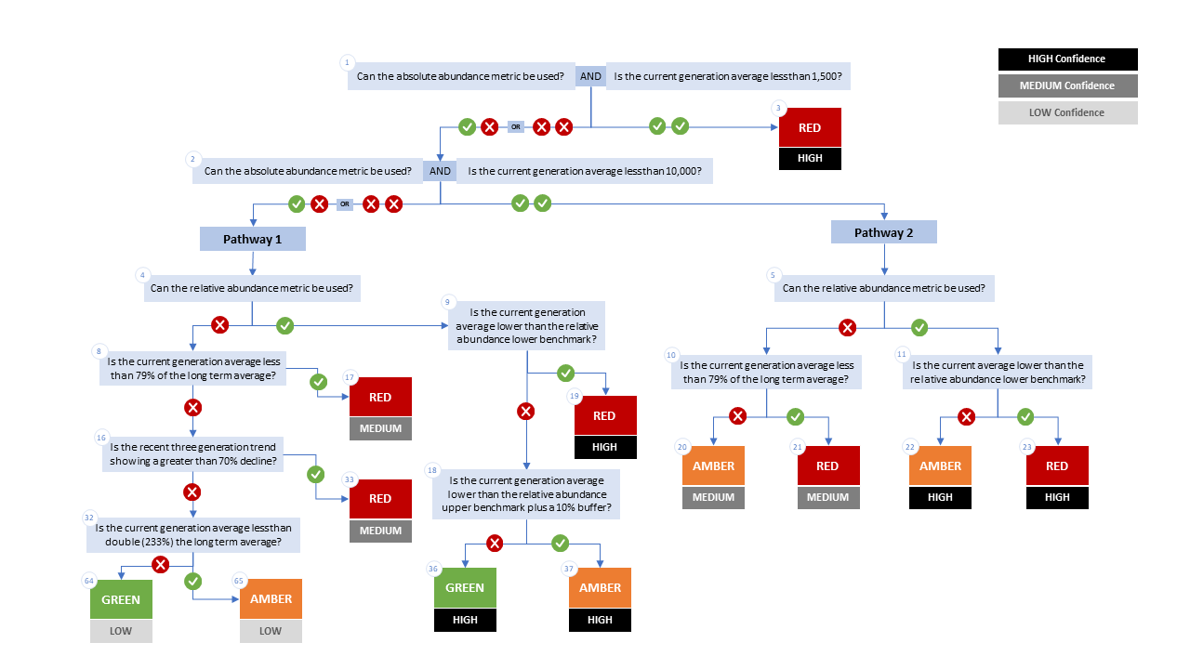

Figure A1. WSP rapid status decision tree (Table 2 includes written descriptions). To assess a CU, metric values are compared to thresholds presented at each decision point. Yes or No answers split each path of the decision tree, terminating at WSP rapid status assignments. The different splits are identified as nodes: 1 to 65. Pathway 1 is taken when the CU has no absolute abundance data, or these data exist, but fall above its upper threshold of 10,000. Pathway 2 is taken when the CU has absolute abundance data and these fall under its upper benchmark of 10,000.

Appendix B: Meeting History and Participants
Tables and summaries of meetings and participants, specifically participants who identified as a subject matter expert for one or more CUs.
Table B1. Participants for the expert review of Fraser Interior Area Chinook held January 31, 2025 1:00-4:30pm PST
Attendee | Affiliation
Chuck Parken | DFO
Colin Bailey | DFO
Morgan Dunne | DFO
Nicole Trouton | DFO
Amber Messmer | DFO
Sue Grant | DFO
Bronwyn MacDonald | DFO
Simon-Luc Noel | DFO
Isabella Borea | DFO
Marissa Glavas | DFO
Elinor McGrath | Okanagan Nation Alliance
Peter Nicklin | Tŝilhqot’in National Government
Kelsey Campbell | A’Tlegay Fisheries
Michelle Walsh | Shuswap Nation

Consensus: general agreement of group as a whole, or absence of evidence-based opposition to conclusions. Determined by the “weight of evidence” (scientific data, information, and analysis ) where multiple results are reported. In the event of disagreements, equally plausible conclusions can be reported. Dissenting views must be clearly described in the narrative.

